**727721EUIT158**

**SRIKANTH S**

**DAY 4**

**TASK 1:**

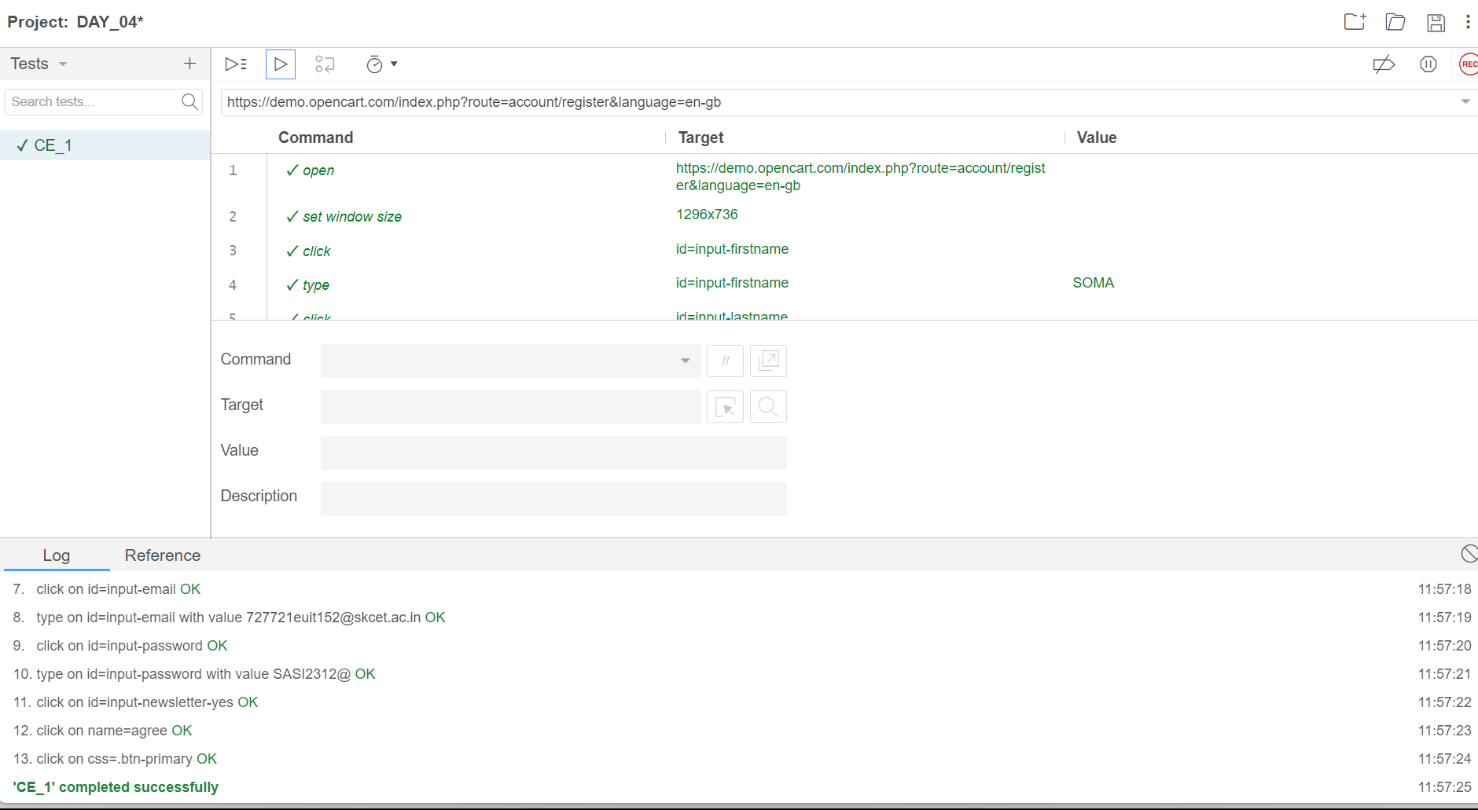

**TASK 2:**

**package** com.demo.demo;

**import** org.openqa.selenium.By;

**import** org.openqa.selenium.WebDriver;

**import** org.openqa.selenium.WebElement;

**import** org.openqa.selenium.chrome.ChromeDriver;

**import** org.openqa.selenium.chrome.ChromeOptions;

**import** io.github.bonigarcia.wdm.WebDriverManager;

**public** **class** CE02 {

**public** **static** **void** main(String[] args) **throws** InterruptedException {

// **TODO** Auto-generated method stub

ChromeOptions co=**new** ChromeOptions();

co.addArguments("--remote-allow-origins=*");

WebDriverManager.*chromedriver*().setup();

WebDriver driver=**new** ChromeDriver(co);

// driver.get("https://www.google.com/");

// CE 02

driver.navigate().to("https://demo.opencart.com/index.php?route=account/register&language=en-gb");

WebElement fname=driver.findElement(By.*id*("input-firstname"));

fname.sendKeys("SOMA SUNDARI");

WebElement lname=driver.findElement(By.*id*("input-lastname"));

lname.sendKeys("R");

WebElement email=driver.findElement(By.*id*("input-email"));

email.sendKeys("727721euit152@skcet.ac.in");

WebElement pass=driver.findElement(By.*cssSelector*("input#input-password"));

pass.sendKeys("skcet");

Thread.*sleep*(5000);

WebElement sub=driver.findElement(By.*id*("input-newsletter-yes"));

sub.click();

}

}

**TASK 3:**

**package** com.demo.demo;

**import** org.openqa.selenium.By;

**import** org.openqa.selenium.JavascriptExecutor;

**import** org.openqa.selenium.WebDriver;

**import** org.openqa.selenium.chrome.ChromeDriver;

**import** org.openqa.selenium.chrome.ChromeOptions;

**import** io.github.bonigarcia.wdm.WebDriverManager;

**public** **class** CE03 {

**public** **static** **void** main(String[] args) **throws** InterruptedException {

// **TODO** Auto-generated method stub

ChromeOptions co=**new** ChromeOptions();

co.addArguments("--remote-allow-origins=*");

WebDriverManager.*chromedriver*().setup();

WebDriver driver=**new** ChromeDriver(co);

driver.get("https://demo.opencart.com/index.php?route=checkout/voucher&language=en-gb");

driver.manage().window().maximize();

driver.findElement(By.*xpath*("//input[@id=\"input-to-name\"]")).sendKeys("Usha");

JavascriptExecutor js=(JavascriptExecutor) driver;

js.executeScript("window.scrollBy(0,500)","");

Thread.*sleep*(5000);

driver.findElement(By.*xpath*("//input[@id=\"input-theme-6\"]")).click();

}

}

**TASK 4:**

**package** com.demo.demo;

**import** org.openqa.selenium.By;

**import** org.openqa.selenium.JavascriptExecutor;

**import** org.openqa.selenium.WebDriver;

**import** org.openqa.selenium.chrome.ChromeDriver;

**import** org.openqa.selenium.chrome.ChromeOptions;

**import** io.github.bonigarcia.wdm.WebDriverManager;

**public** **class** CE04 {

**public** **static** **void** main( String[] args ) **throws** InterruptedException

{

ChromeOptions co=**new** ChromeOptions();

co.addArguments("--remote-allow-origins=*");

WebDriverManager.*chromedriver*().setup();

WebDriver driver=**new** ChromeDriver(co);

driver.get("https://j2store.net/free/");

driver.manage().window().maximize();

JavascriptExecutor js=(JavascriptExecutor) driver;

js.executeScript("window.scroll(0,1000)", "");

Thread.*sleep*(3000);

//

driver.findElement(By.*xpath*("/html/body/div[2]/div/div[2]/div/div/div/div/ul/li[1]/h4/a")).click();

driver.navigate().back();

driver.navigate().forward();

driver.navigate().refresh();

driver.close();

}

}

**TASK 5.1:**

**package** com.demo.demo;

**import** org.openqa.selenium.By;

**import** org.openqa.selenium.WebDriver;

**import** org.openqa.selenium.chrome.ChromeDriver;

**import** org.openqa.selenium.chrome.ChromeOptions;

**import** io.github.bonigarcia.wdm.WebDriverManager;

**class** CE05 {

**public** **static** **void** main(String[] args) {

// **TODO** Auto-generated method stub

ChromeOptions co=**new** ChromeOptions();

co.addArguments("--remote-allow-origins=*");

WebDriverManager.*chromedriver*().setup();

WebDriver driver=**new** ChromeDriver(co);

driver.get("https://j2store.net/free/");

driver.manage().window().maximize();

String currentUrl=driver.getCurrentUrl();

String expectedUrl="https://j2store.net/free/";

**if**(currentUrl.equals(expectedUrl)) {

System.***out***.println("URL Matched");

}

**else** {

System.***out***.println("URL not Matched");

}

driver.findElement(By.*xpath*("//*[@id=\"Mod112\"]/div/div/ul/li[1]/a")).click();

String CUrl=driver.getCurrentUrl();

String EUrl="https://j2store.net/free/index.php/shop?filter_catid=11";

**if**(CUrl.equals(EUrl))

{

System.***out***.println("URL MATCHED");

}

**else**

{

System.***out***.println("URL NOT MATCHED");

}

driver.close();

}

}

**OUTPUT:**

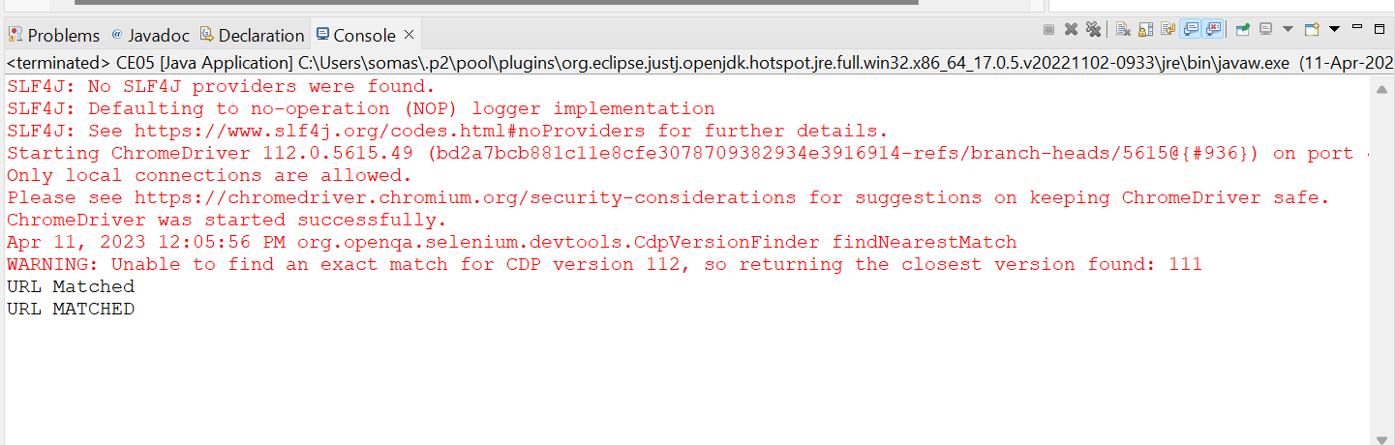

**TASK 5.2:**

**package** com.demo.demo;

**import** java.util.List;

**import** org.openqa.selenium.By;

**import** org.openqa.selenium.WebDriver;

**import** org.openqa.selenium.WebElement;

**import** org.openqa.selenium.chrome.ChromeDriver;

**import** org.openqa.selenium.chrome.ChromeOptions;

**import** io.github.bonigarcia.wdm.WebDriverManager;

**public** **class** CE05_2 {

**public** **static** **void** main( String[] args ) **throws** InterruptedException

{

ChromeOptions co=**new** ChromeOptions();

co.addArguments("--remote-allow-origins=*");

WebDriverManager.*chromedriver*().setup();

WebDriver driver=**new** ChromeDriver();

driver.get("https://j2store.net/free/");

driver.manage().window().maximize();

driver.findElement(By.*xpath*("/html/body/div[2]/div/div[2]/div/div/div/div/ul/li[1]/h4/a")).click();

Thread.*sleep*(3000);

List<WebElement> li=driver.findElements(By.*xpath*("//h2[@itemprop=\"name\"]"));

**for** (WebElement link:li) {

System.***out***.println(link.getText());

}

}

}

**OUTPUT:**

